Jenkins

S3 static website hosting:

Generating bucket policy.

Go to policy generator

Select the type of policy—S3 bucket policy

Effect—allow

Principal--*

AWS service—Amazon S3

getObject—action

what is Jenkins?

You need to build the code.

Artifacts—

Jenkins build the code and deploy the code into target environment.

Build code is done by maven

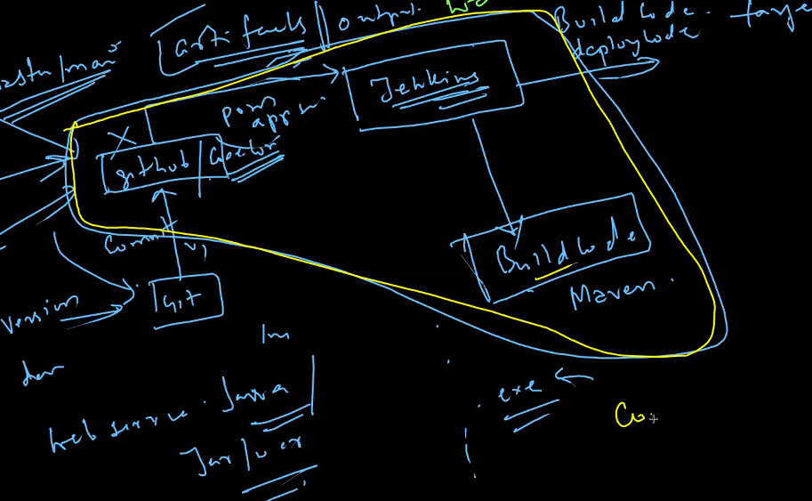

Commiting the code and deploying in the target environment is called continuous integration

Code🡪build code🡪deploy code🡪production

---------------------------

Continuos integration

Continuos delivery needs a manual approval

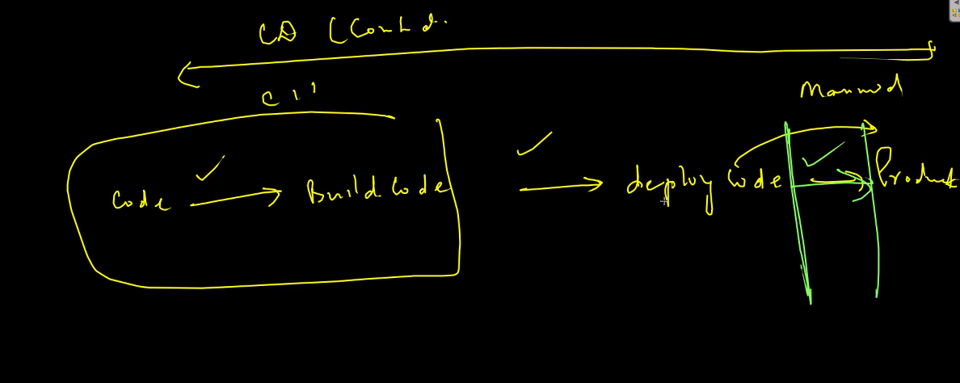

Continuous deployment—no need of approval manually

Continuous delivery need manual approval.

<https://maven.apache.org/what-is-maven.html>

go to aws

create an ec2 instance—choose linux 2 ami only—create security group –ssh,custom tcp-port 8000—http,https-anywhere –create

connect

cd downloads

ssh command

sudo su

yum update

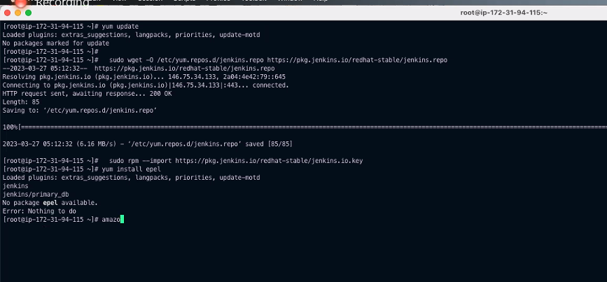

ipaddress:8080

create a new job🡪enter an item name🡪

free style project

general🡪give some description

source code management -none

build triggers🡪

build steps; execute shell

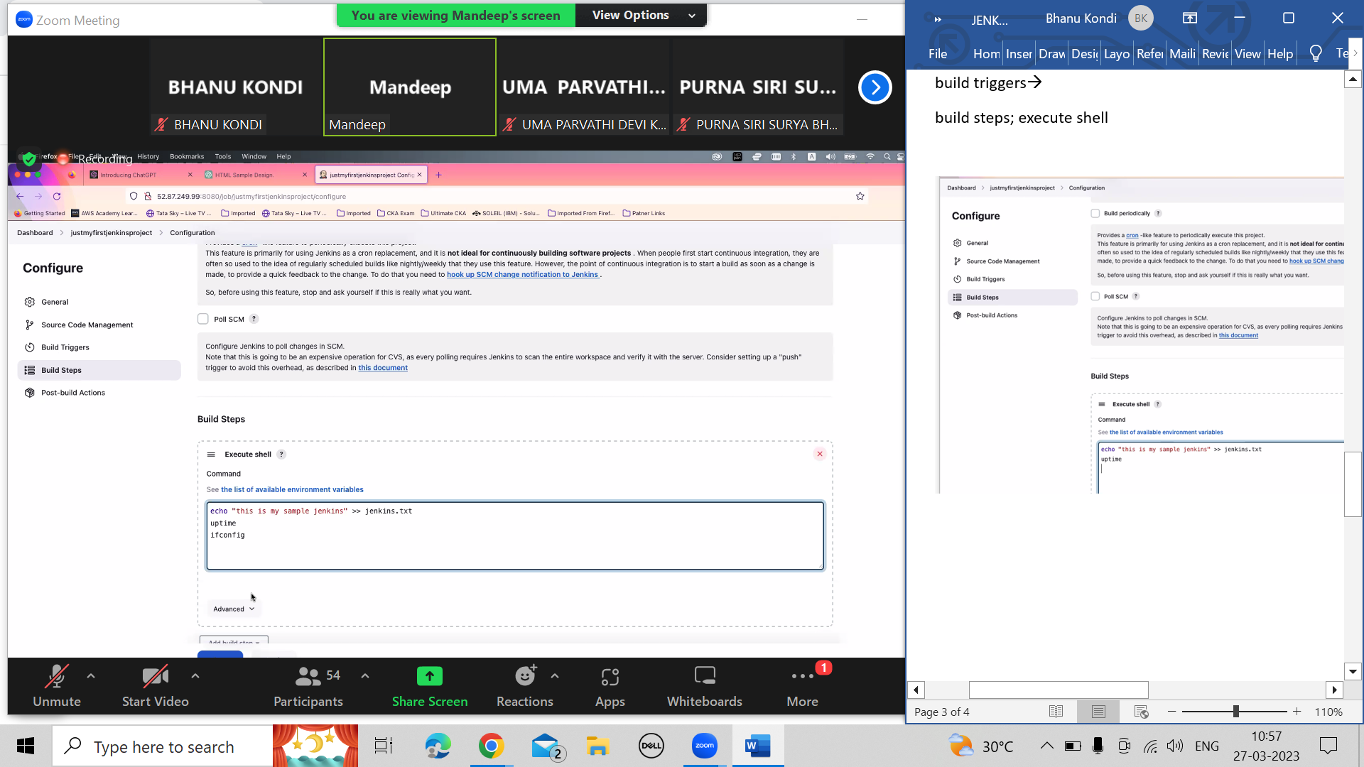

Apply and save

Left corner –go to build run—go to console output

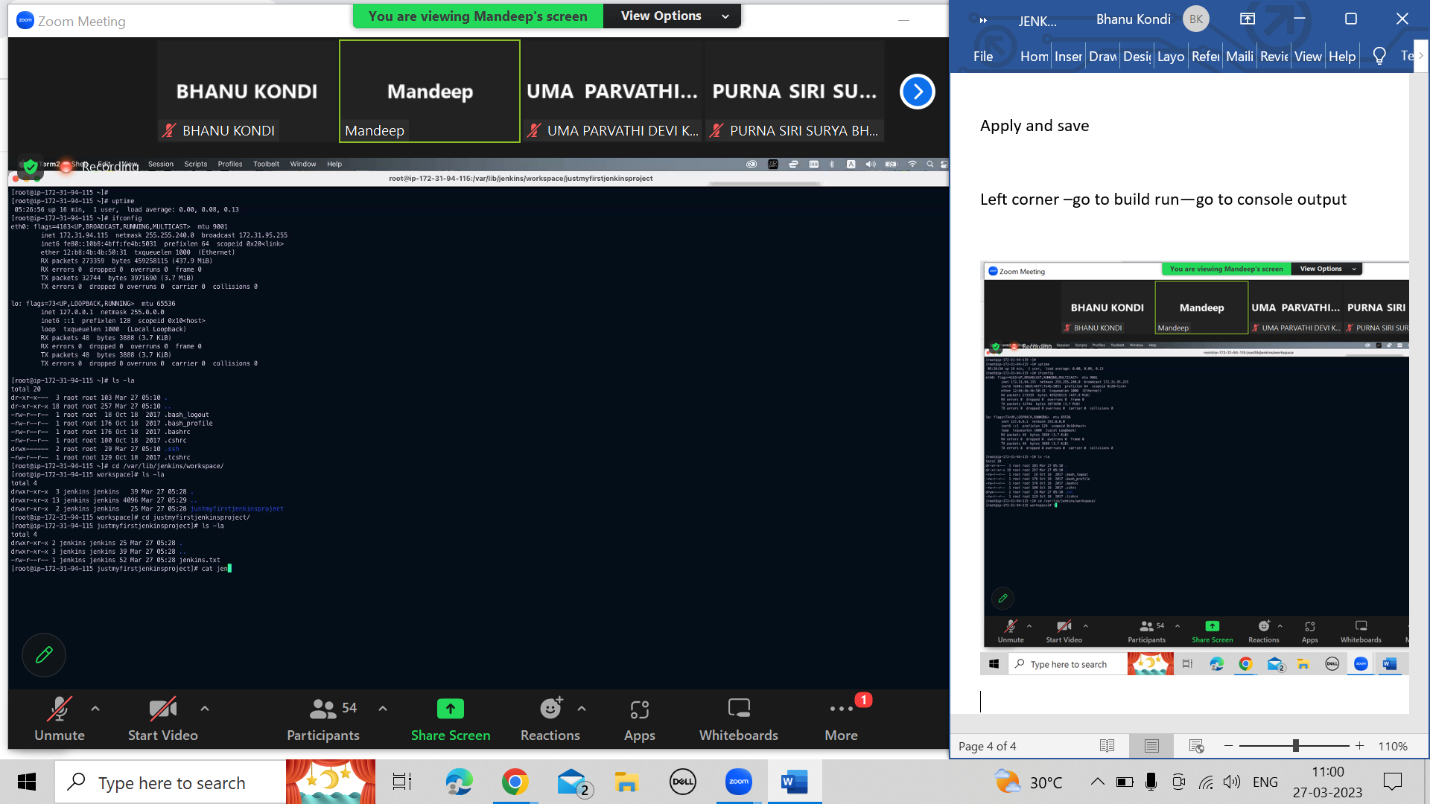

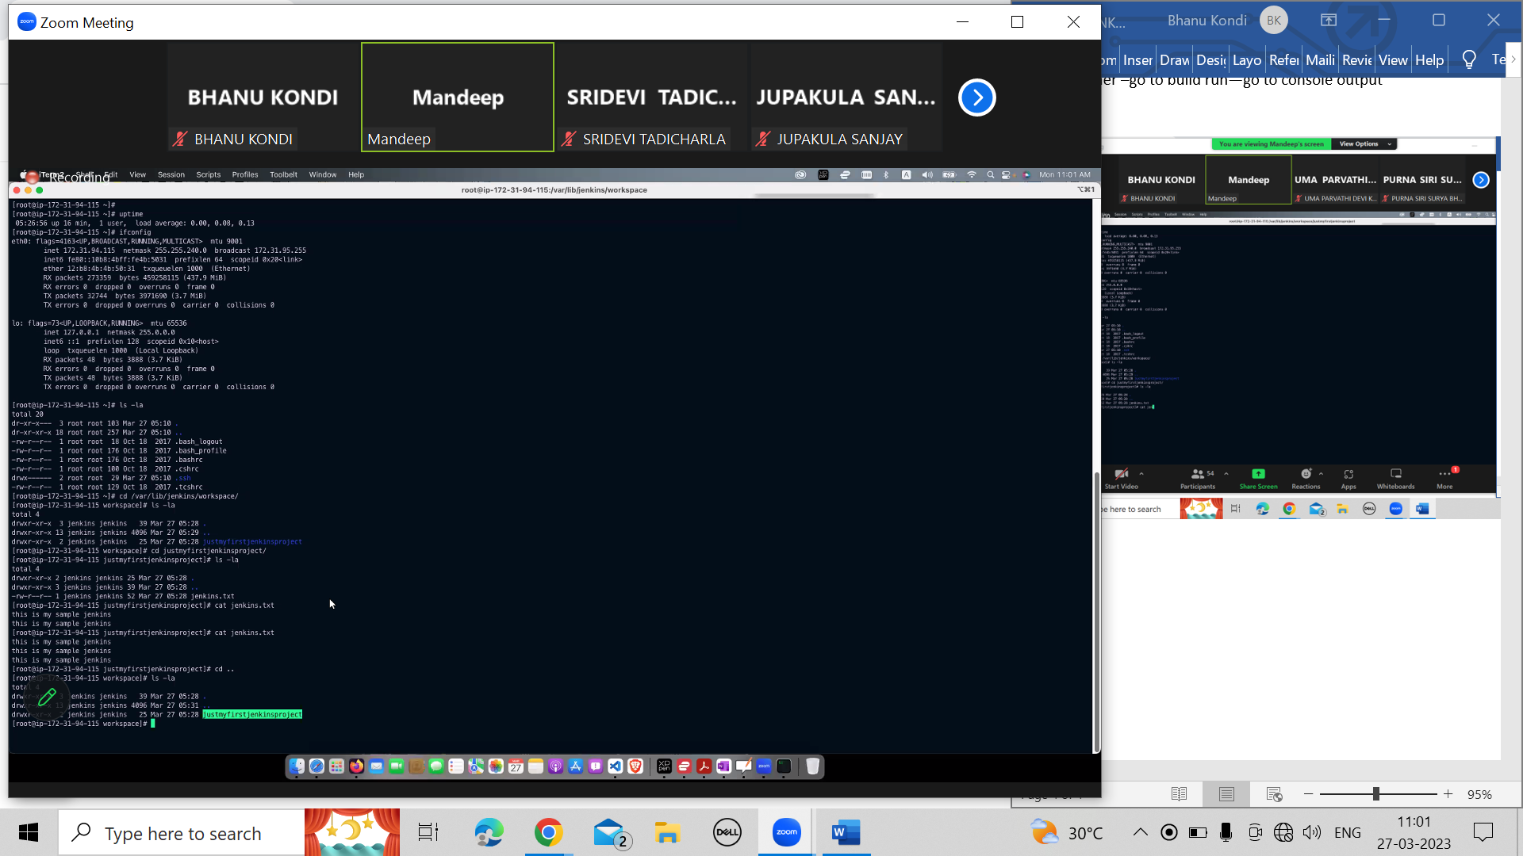

Workspace will be allocated based on jtem only

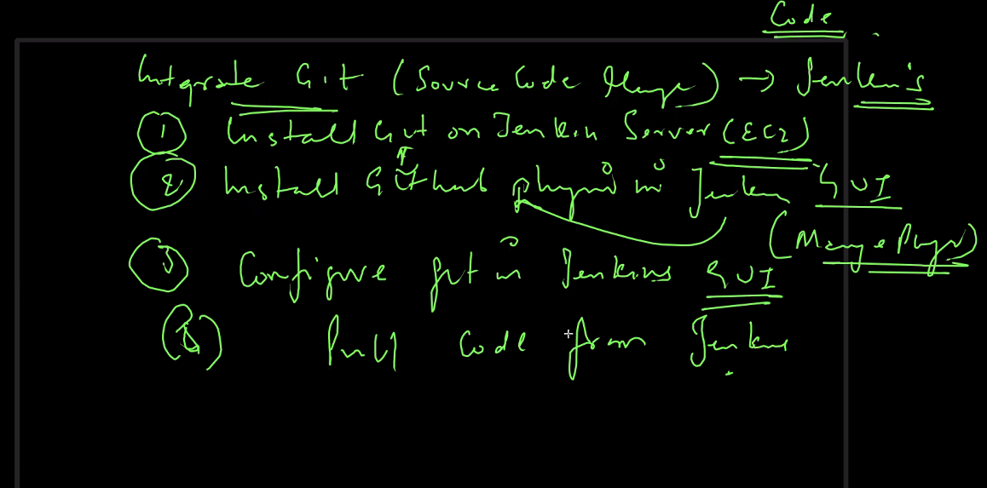

Got to the instance

Cd

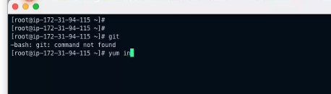

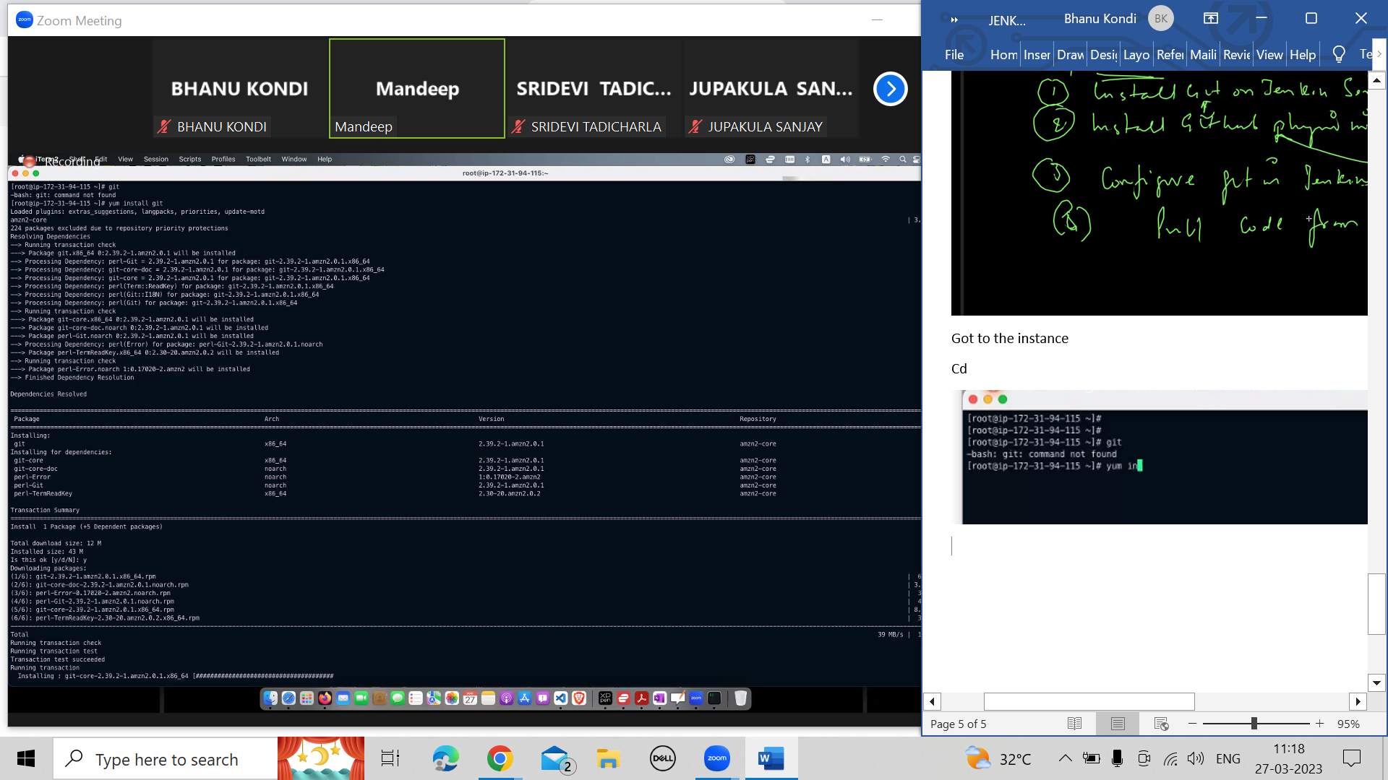

Git –version

In Jenkins gui install github plugin

Throw throws catch multi catch,custom exception classes

Dashboard🡪manage plugins🡪available plugins🡪github

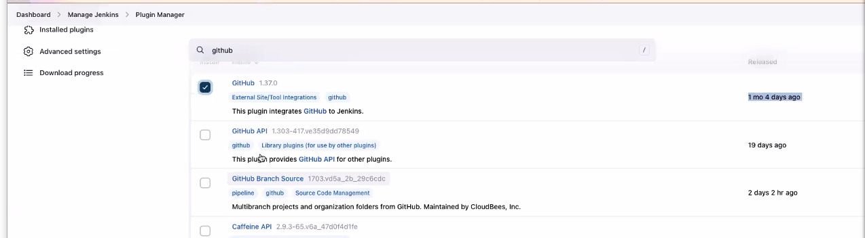

Go to maange Jenkins—manage plugins🡪installed plugins

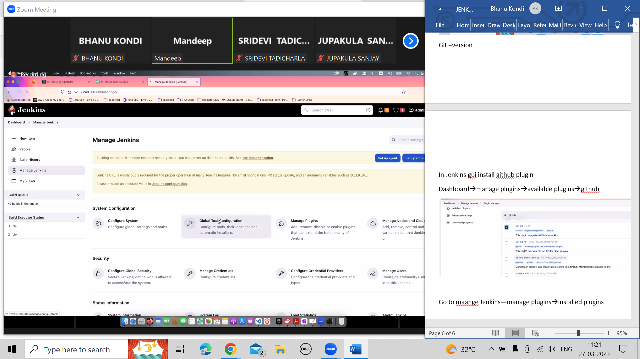

Global tool configuration

Name-git

Path to git executable—git

Apply and save

Go to new item

Pullcommandfromgithub

Freestyle project

Ok

Source code management—git

General description

Choose git—give url of the repository

<https://github.com/jhamandeep/hello-world>

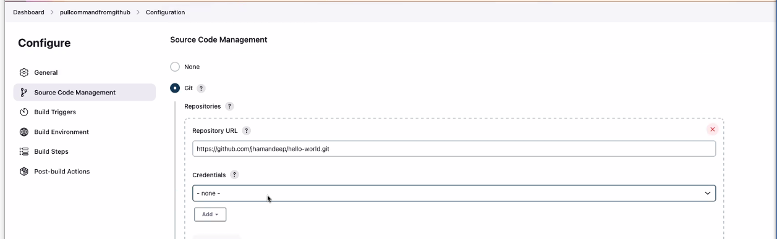

copy https link

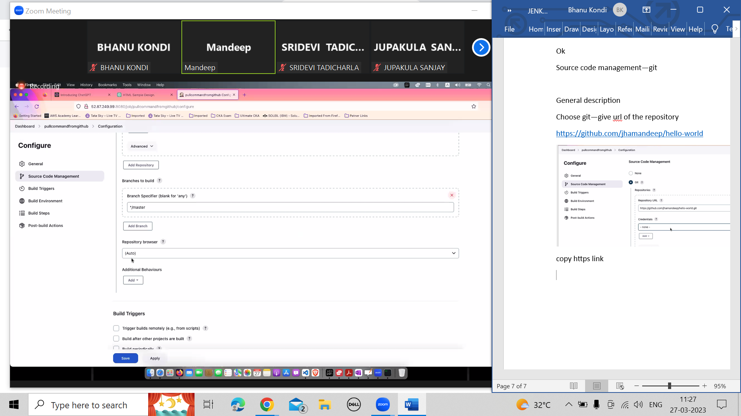

Apply and save

Click on build now

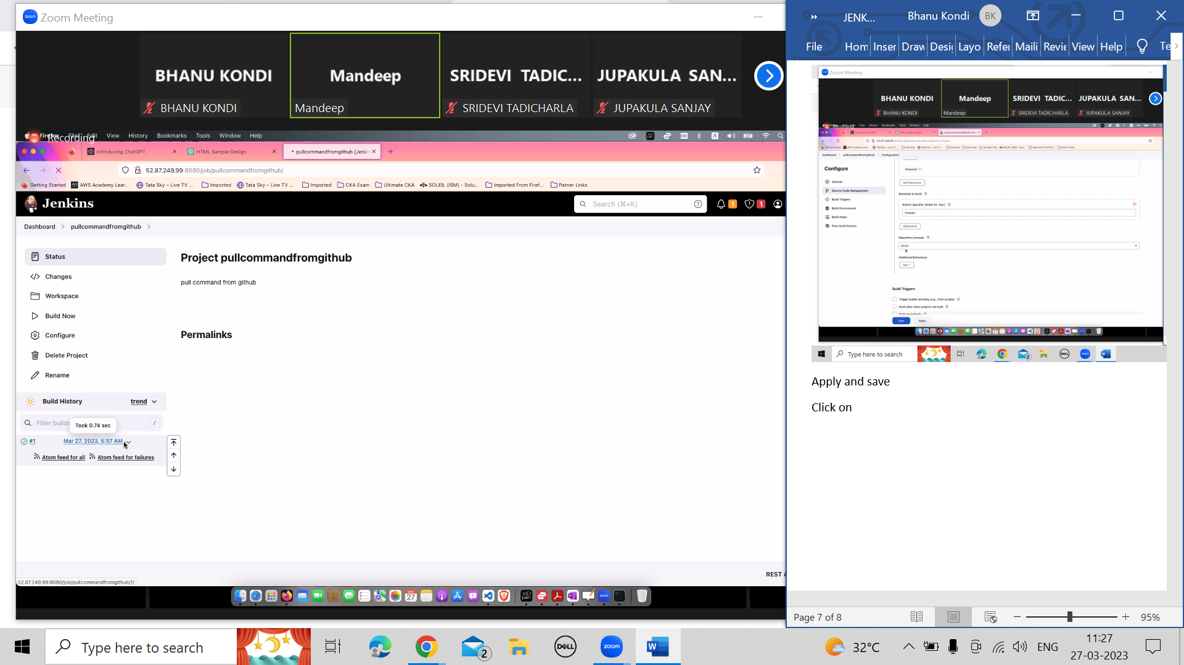

Open console output.

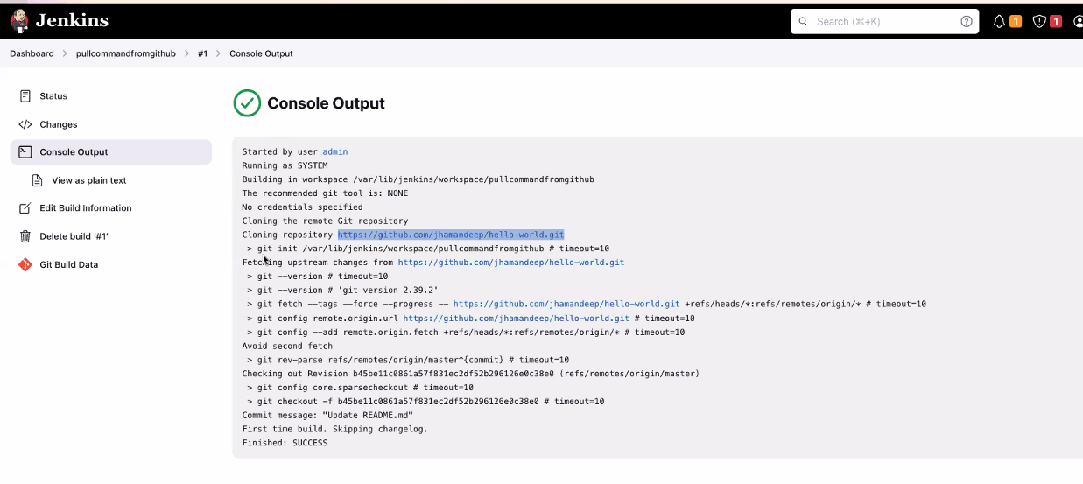

Go to command prompt(where you have logged in to ec2 instnace)

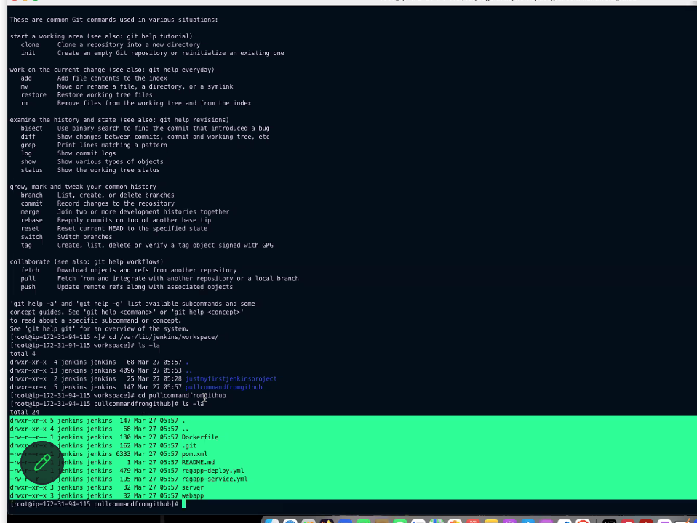

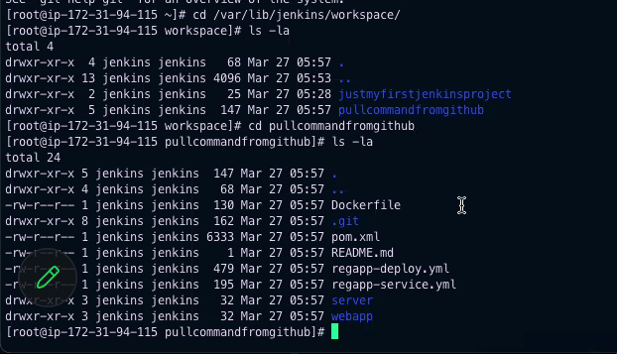

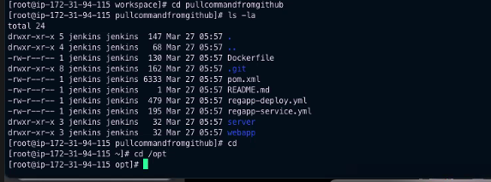

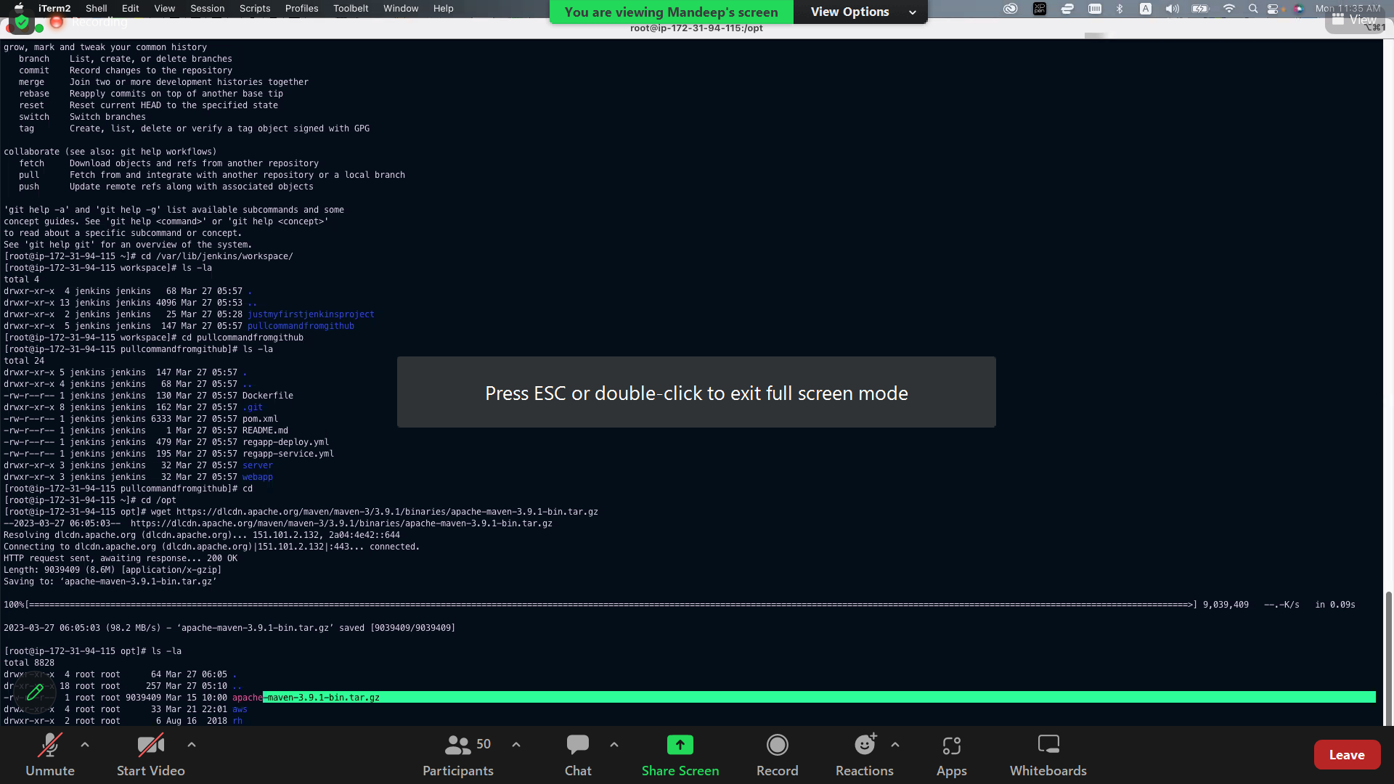

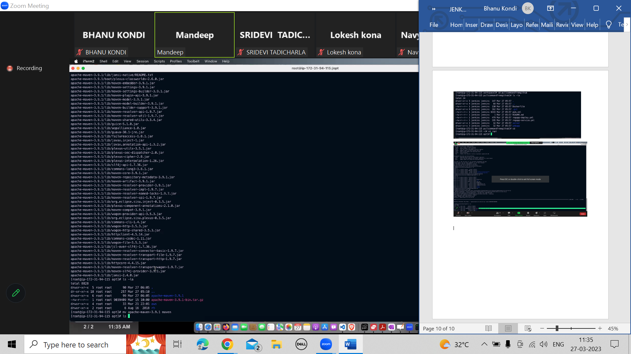

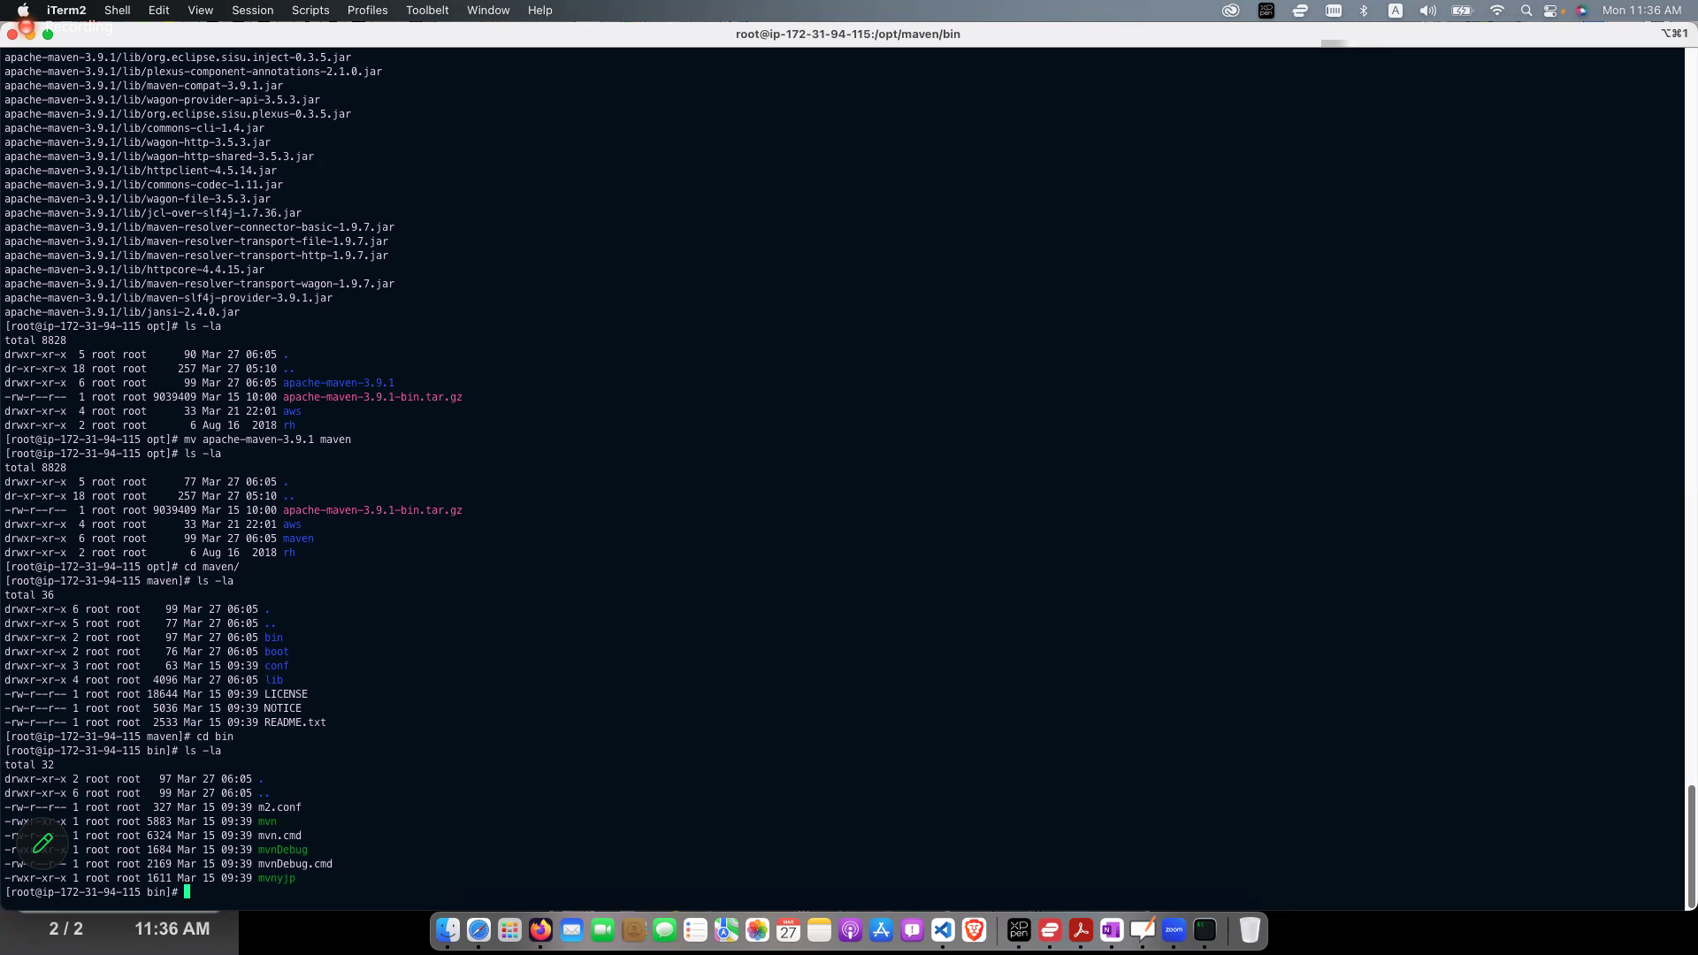

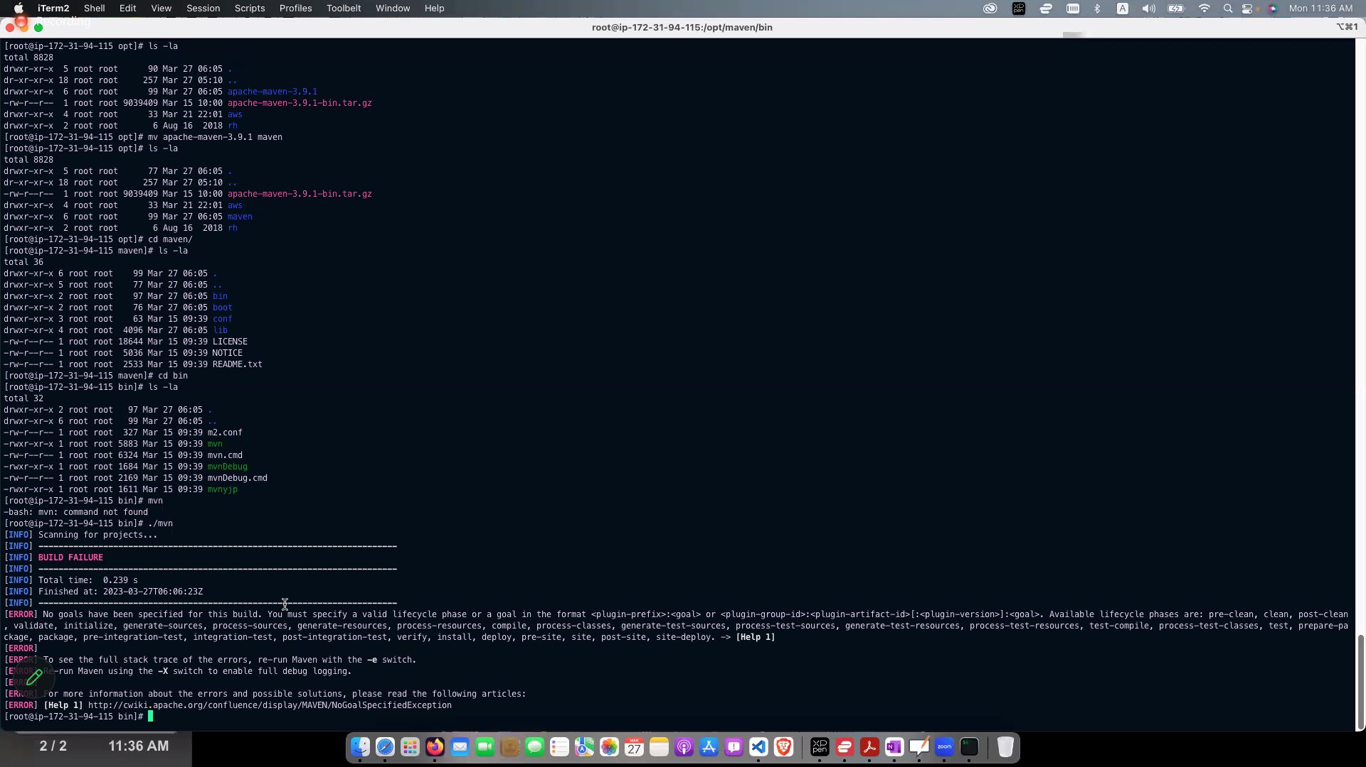

Login to insrance again

Sudo su

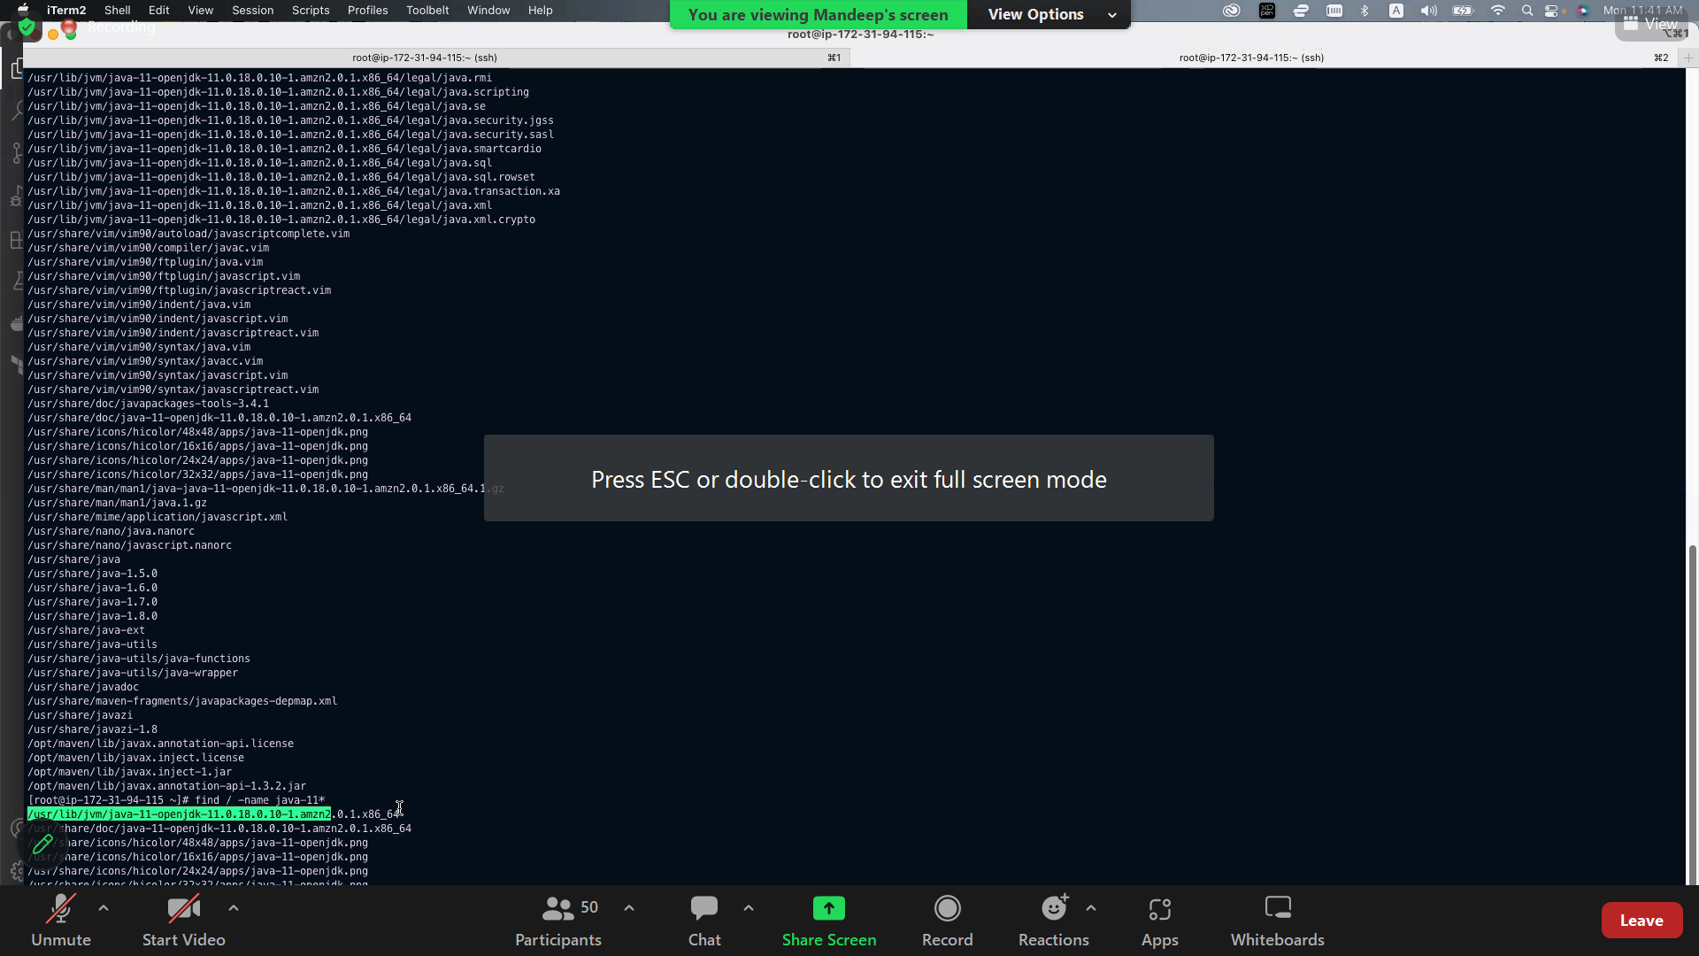

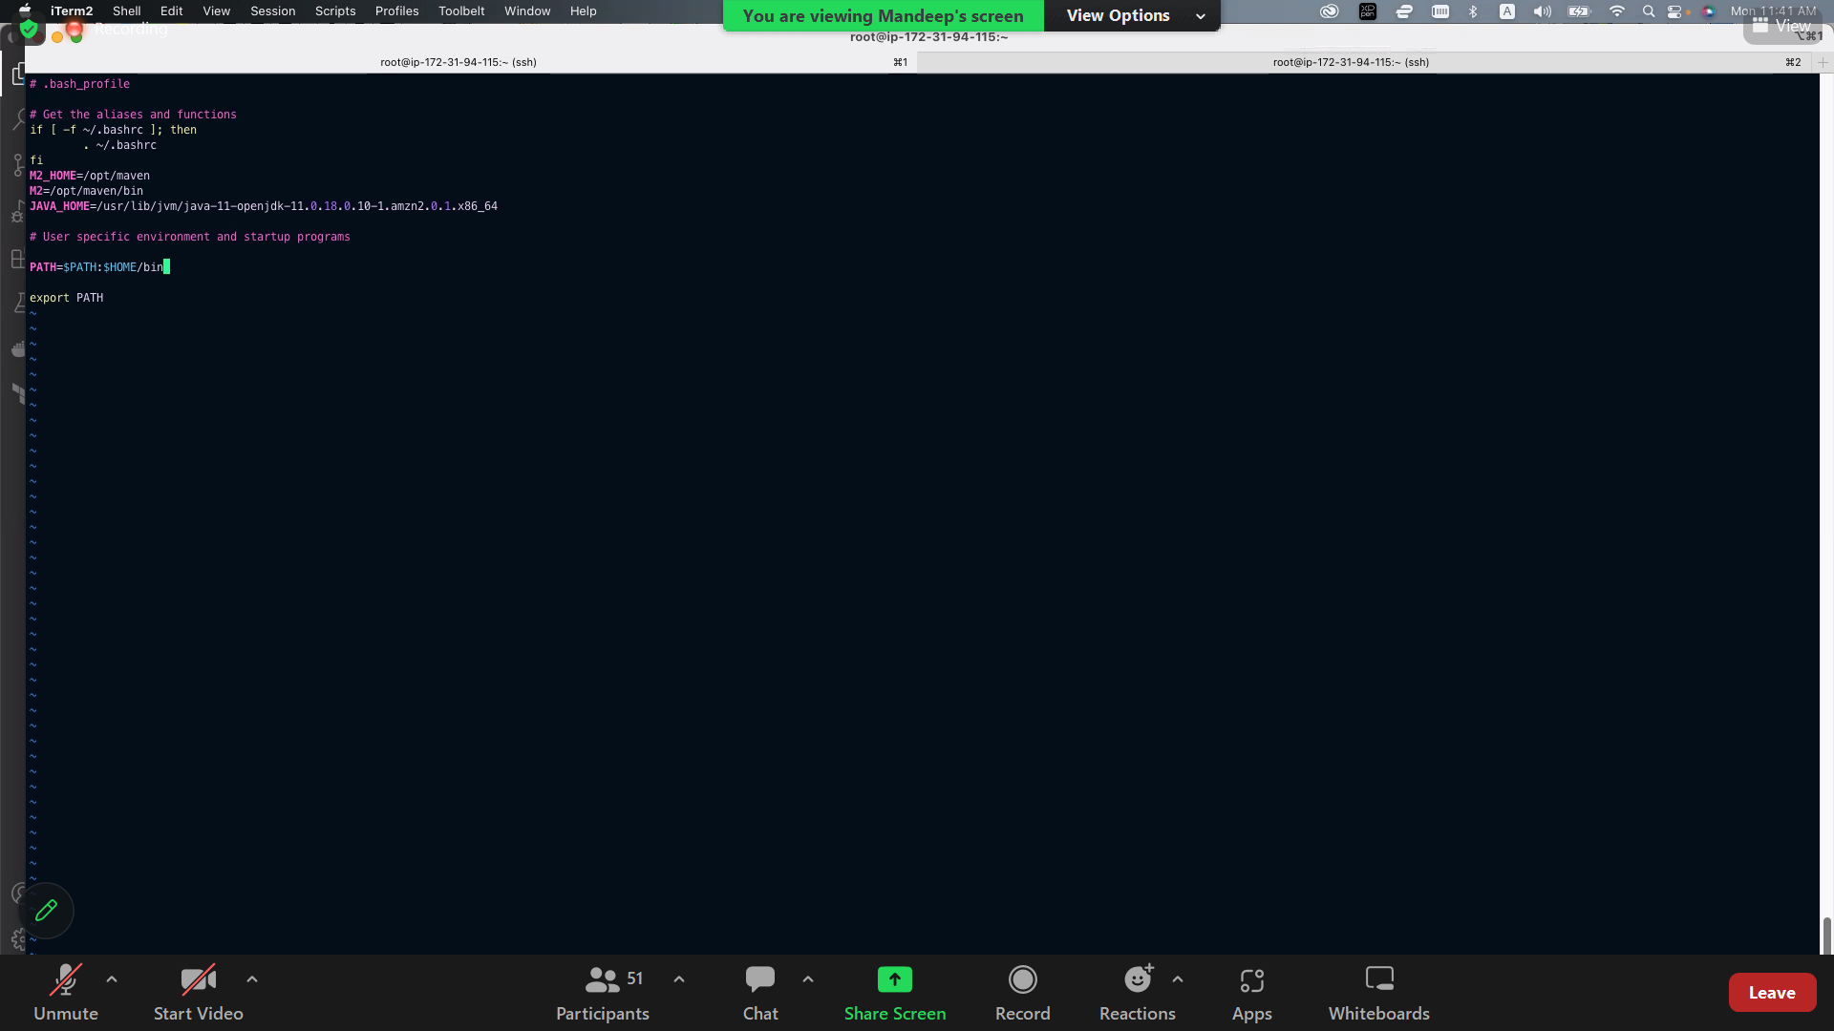

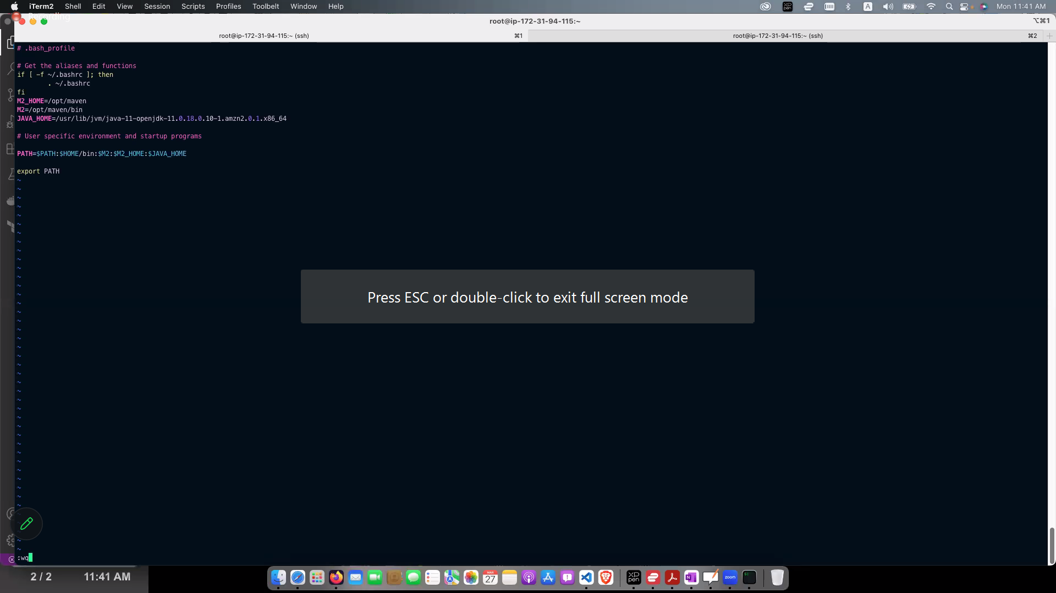

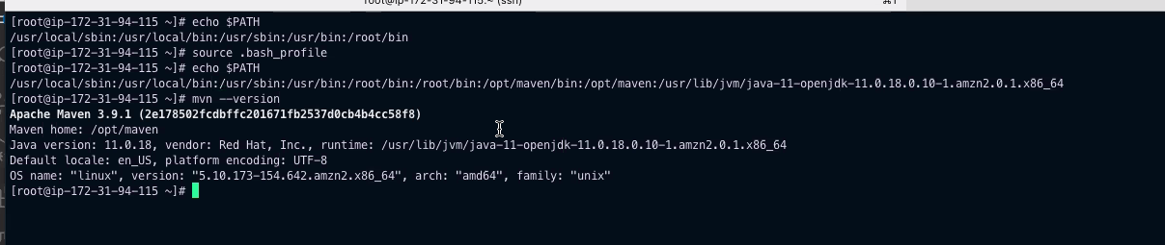

install maven plugin

global tool config

name-maven

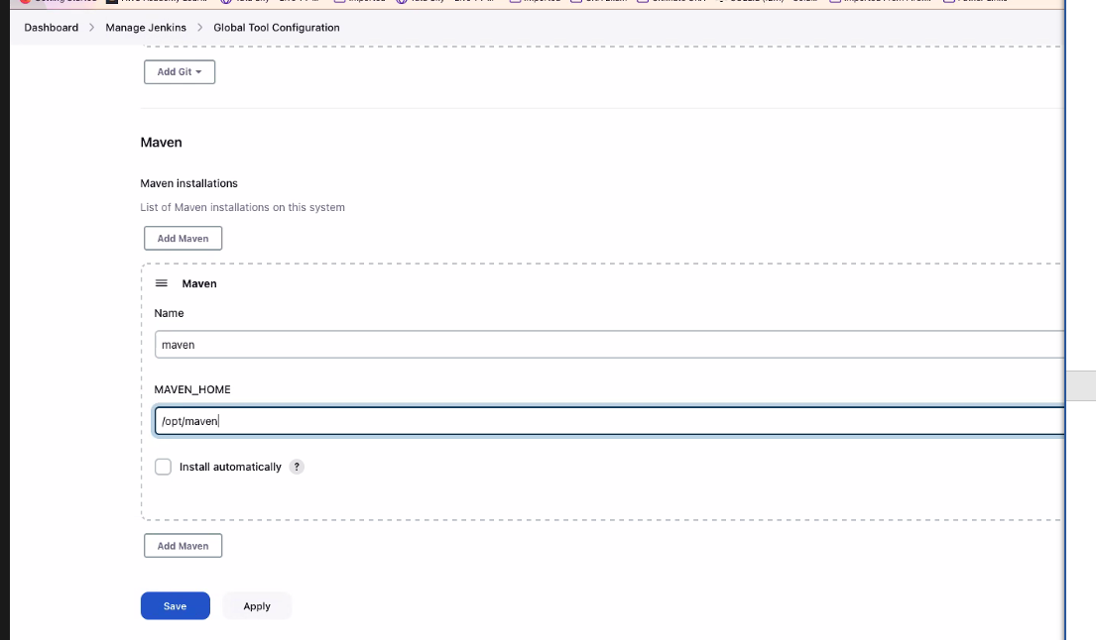

apply ans save

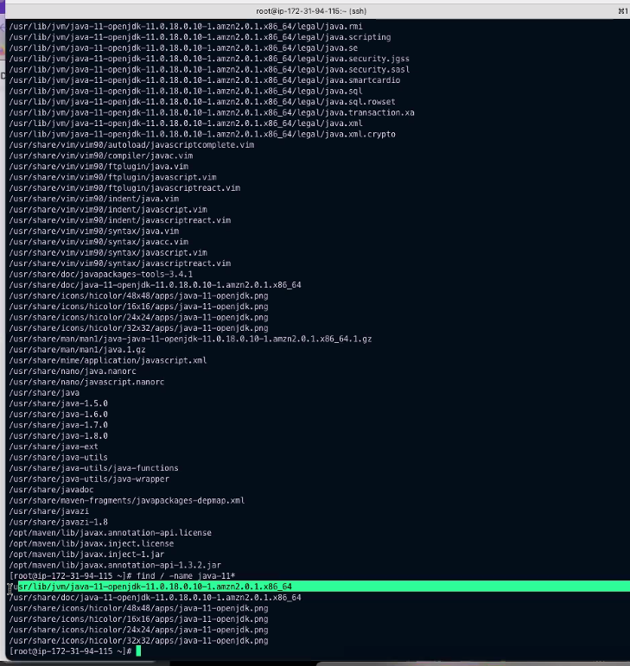

copu the path in jdk (global tool config)\

go to dashboard

new item

-firstmaven

select maven project

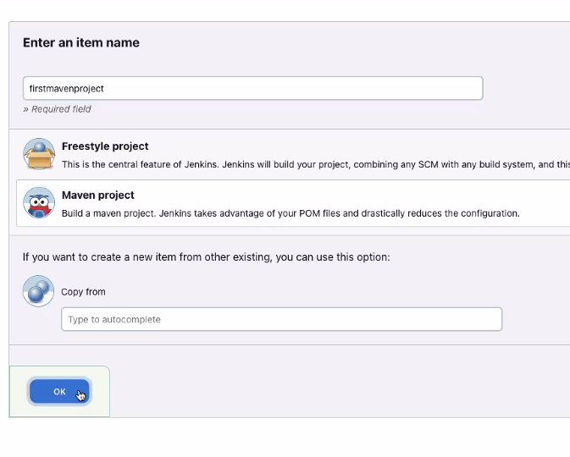

Give general description

Git—provide repository url

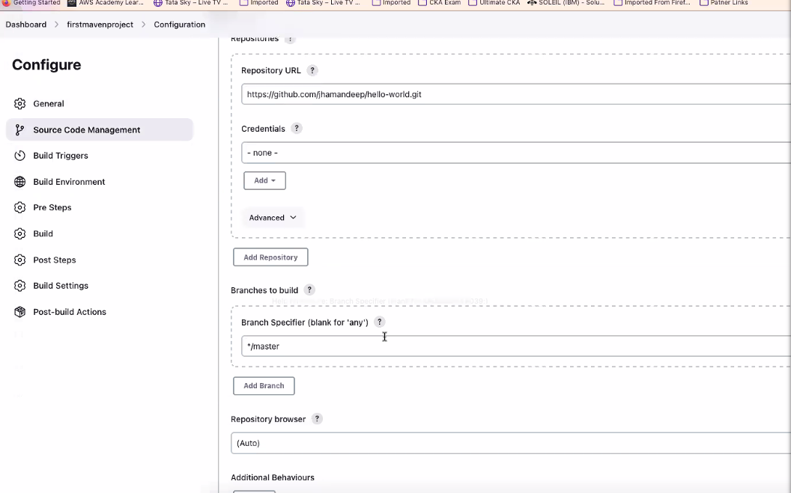

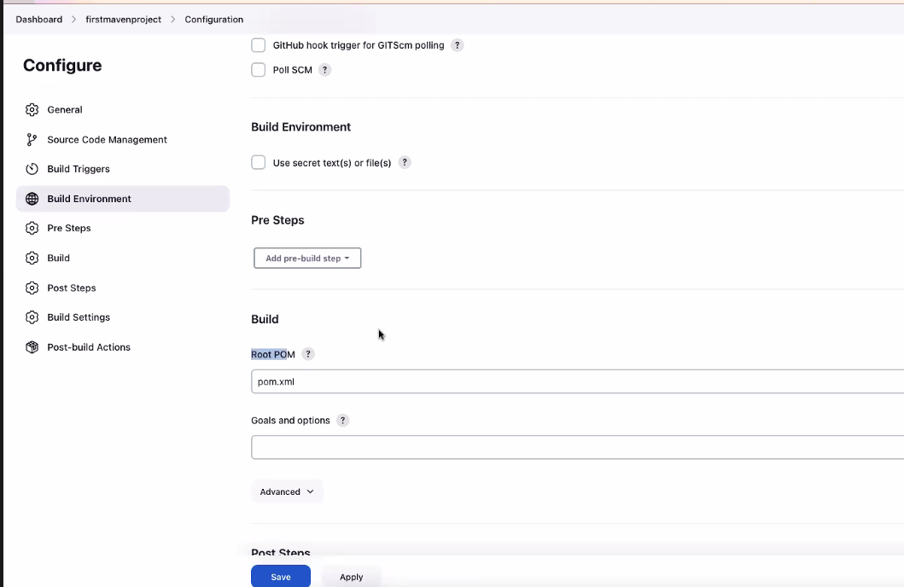

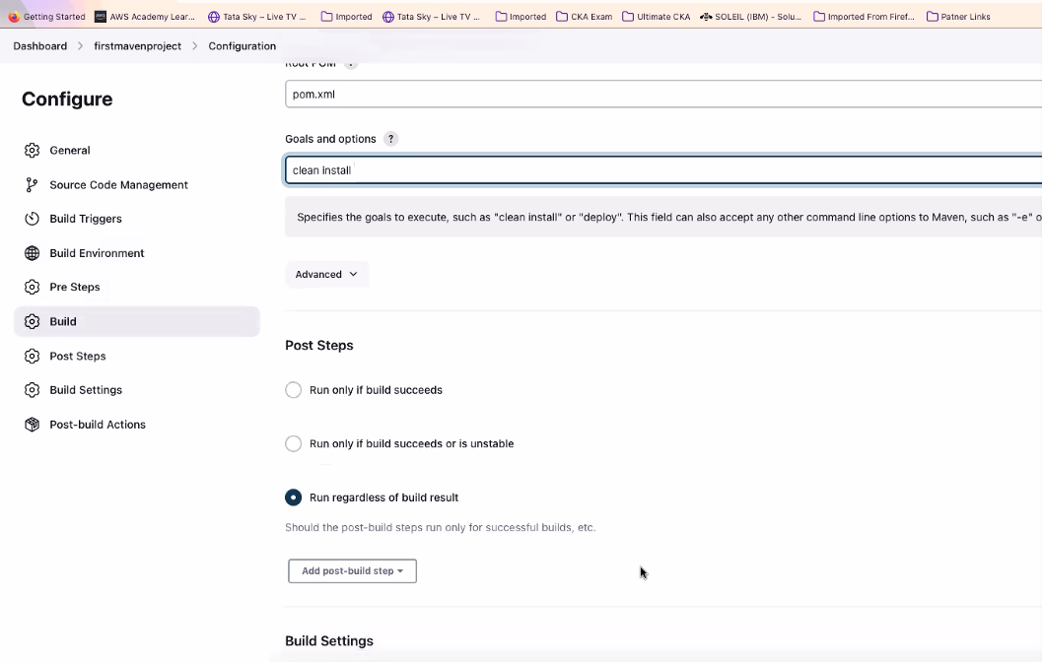

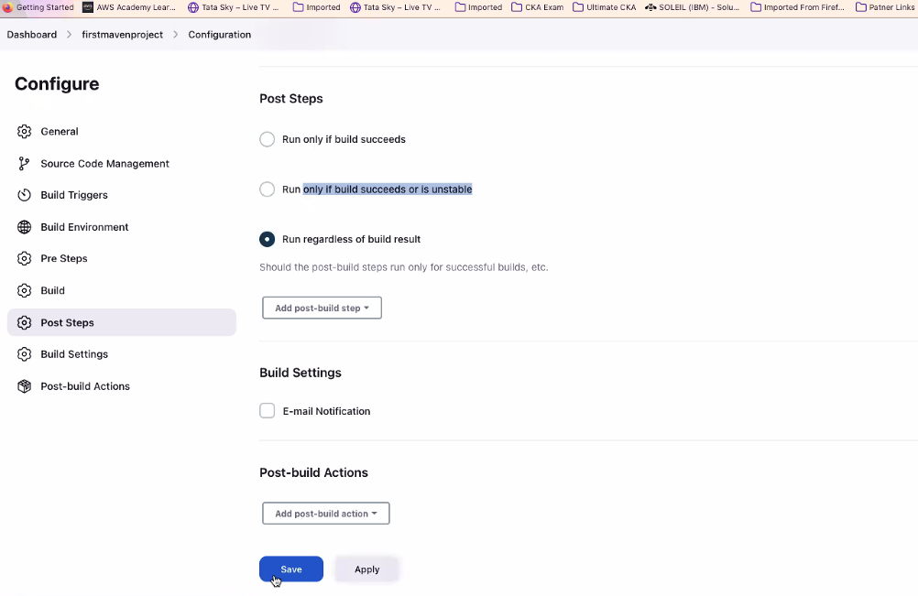

Build now

Console output

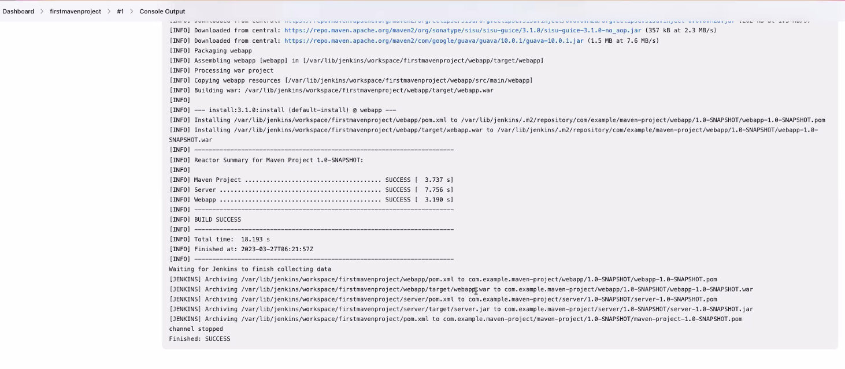

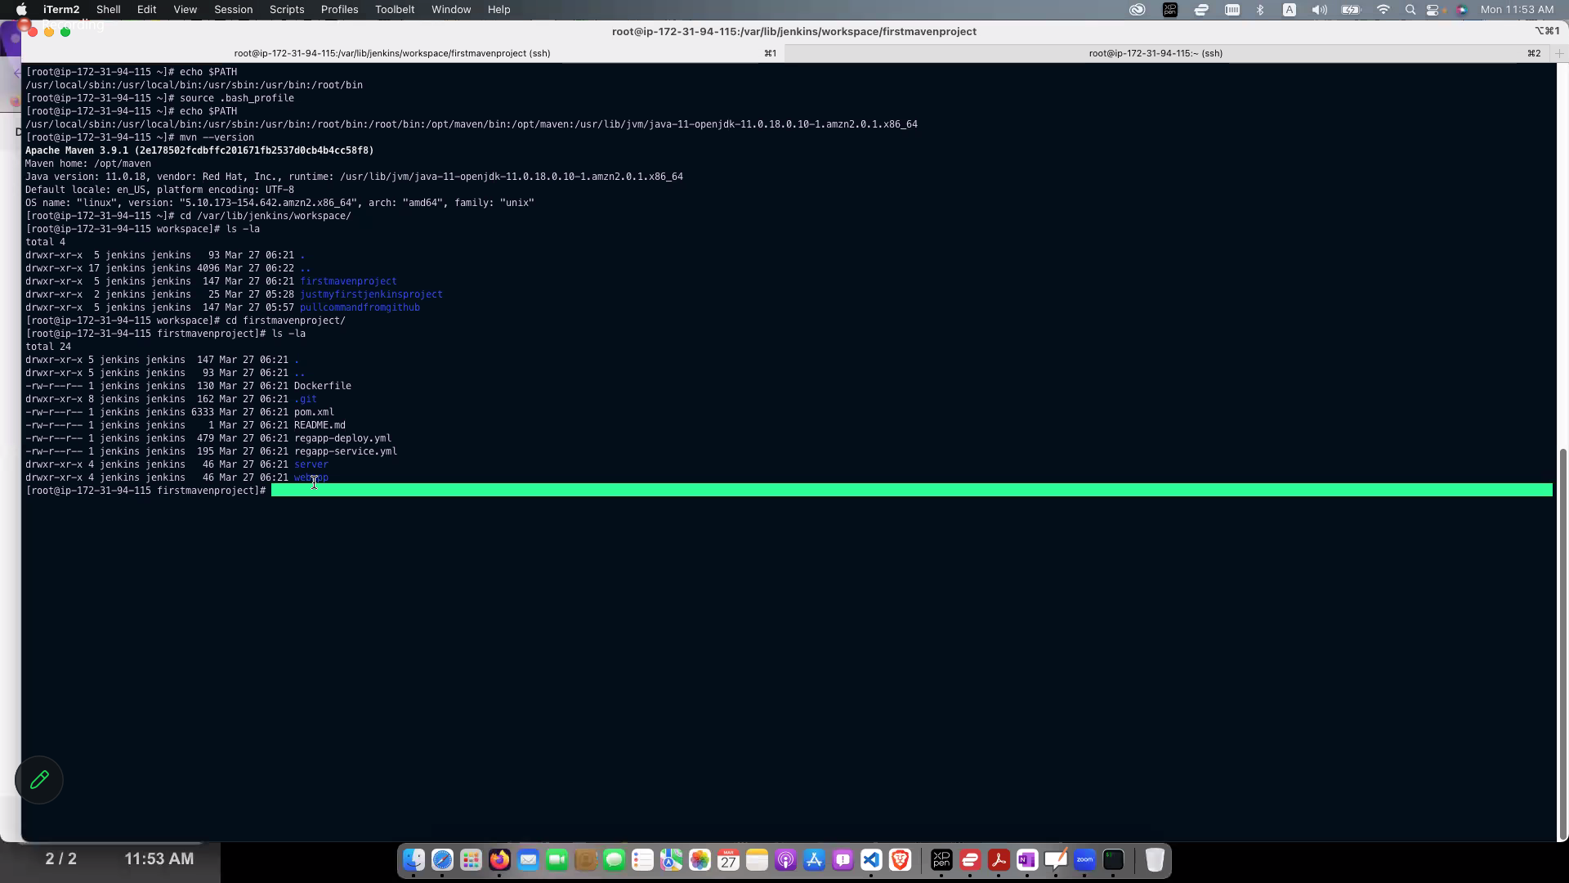

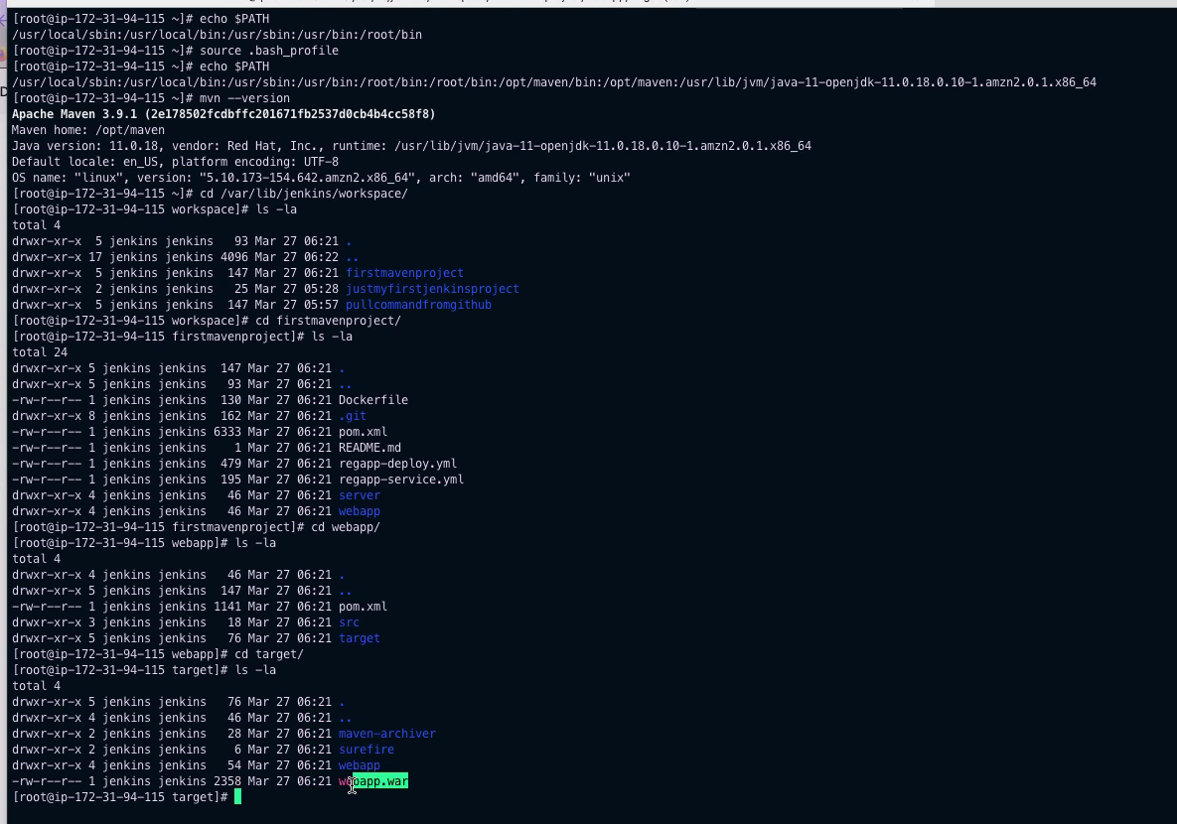

Maven

Suppose you have java source code and you have environment,

Maven builds a code for u,it will combine all the source files intoan archive f**ile.**

**Complete the setup which ,sir told in the class**

**You already installed Jenkins**

**1.change password**

**2.integrate git with Jenkins , install git in Jenkins server,install github plugin**

**Configure git on Jenkins gui**

**Manage plugins-available-github-global-toolconfig—**

**Open your github and fork the sir repository**

**Pull command**

**Install maven**

**Use Jenkins server**

**Apache maven download page—maven download link**

[**https://dlcdn.apache.org/maven/maven-3/3.9.1/binaries/apache-maven-3.9.1-bin.tar.gz**](https://dlcdn.apache.org/maven/maven-3/3.9.1/binaries/apache-maven-3.9.1-bin.tar.gz)

**after installing setup the environment---cd .bash_profile**

**nano**

**add m2 ,and rename maven**

**what is the difference between continuous delivery and continuous development**

**Continuous Development and Continuous Delivery are two related concepts in software development and deployment, both of which are commonly used in Jenkins.**

**Continuous Development (CD) is the practice of continuously integrating and testing code changes as they are made, in order to catch issues and ensure the code is always in a working state. This involves frequent automated builds and tests, as well as continuous integration and deployment.**

**Continuous Delivery (CD), on the other hand, is the process of automating the release of code to production, with the goal of ensuring that the code is always in a deployable state. This involves automating the build, test, and deployment process, and integrating it with the continuous integration process to ensure that code is always in a deployable state.**

**In Jenkins, Continuous Development involves using tools like Git and Maven to automate the build and test process, and to integrate code changes into the main code base. Continuous Delivery involves using tools like Docker and Kubernetes to automate the deployment of code changes to production.**

**In summary, Continuous Development focuses on ensuring that code changes are integrated and tested continuously, while Continuous Delivery focuses on automating the release of code changes to production. Both CD and CD are critical components of modern software development practices, and Jenkins provides powerful tools to support both of these practices.**

**ci/cd**

**what is jenkins?**

**Jenkins is an open-source automation tool used for continuous integration and continuous delivery (CI/CD) of software projects. It provides a platform for automating the building, testing, and deployment of software applications, making it easier to manage and release software updates quickly and efficiently.**

**Jenkins is designed to work with a variety of programming languages and technologies, including Java, Python, Ruby, and many others. It integrates with other tools and services, such as Git, Maven, and Docker, allowing for a flexible and customizable development pipeline.**

**Jenkins provides a user-friendly web interface for managing projects and creating pipelines, as well as a wide range of plugins to extend its functionality. It also has a large and active community of developers and users, who contribute to its development and provide support and resources to others using the tool.**

**Overall, Jenkins is a powerful and flexible tool for automating software development and deployment, making it a popular choice for both small and large software development teams.**

**what is maven?**

**Maven is an open-source build automation tool used primarily for Java projects. It helps manage and organize a project's build, documentation, and dependencies. Maven provides a standard way to build and manage Java projects, allowing developers to focus on writing code rather than dealing with complex build configurations.**

**Maven uses a Project Object Model (POM) file to describe the project structure, its dependencies, and the build process. The POM file includes information such as the project name, version, dependencies, build plugins, and repositories. This information is used by Maven to automatically download the required dependencies, compile the code, and build the project into a distributable format, such as a JAR or WAR file.**

**One of the key benefits of using Maven is that it provides a standardized build process, making it easier to maintain and update projects. Maven also integrates with other tools and services, such as Jenkins, Git, and Eclipse, allowing for a streamlined development pipeline.**

**In summary, Maven is a powerful build automation tool that simplifies the management of Java projects, allowing developers to focus on writing code rather than dealing with complex build configurations.**

**What is cloud computing?**

**Cloud computing is the delivery of services over the internet with the help of virtualization**

**AWS is a platform as a service.**

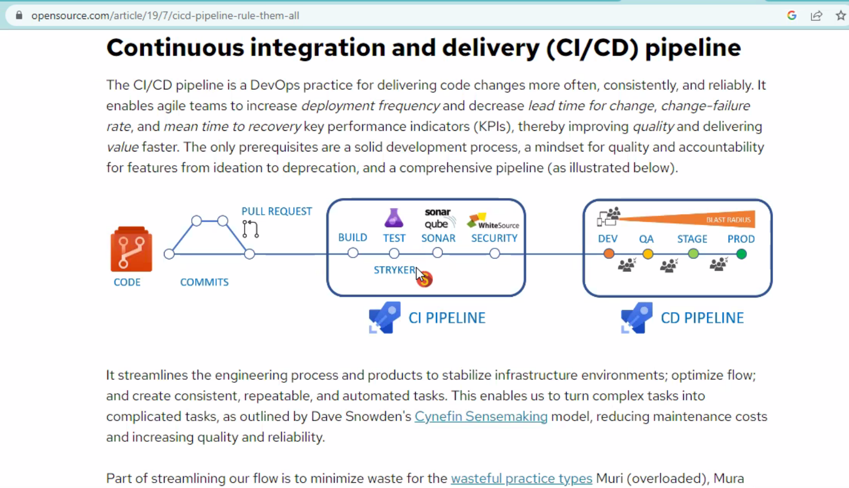

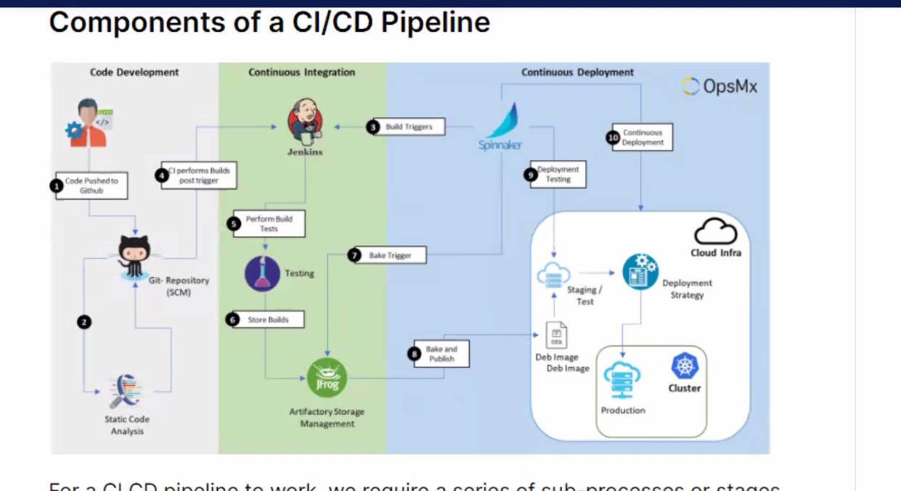

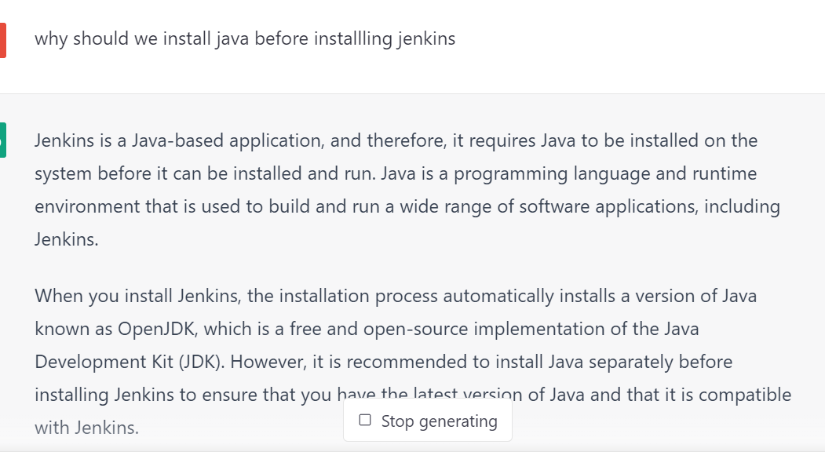

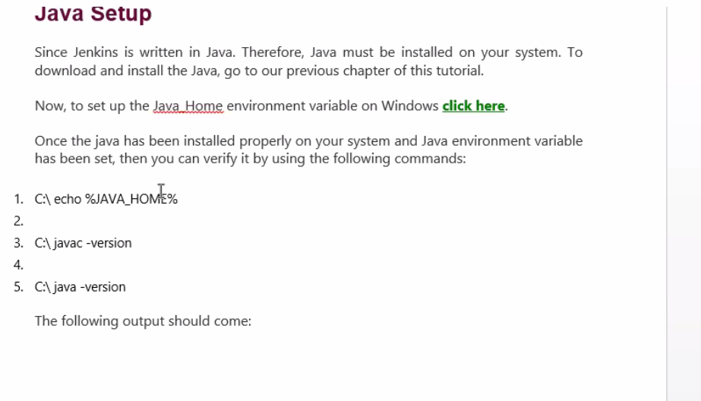

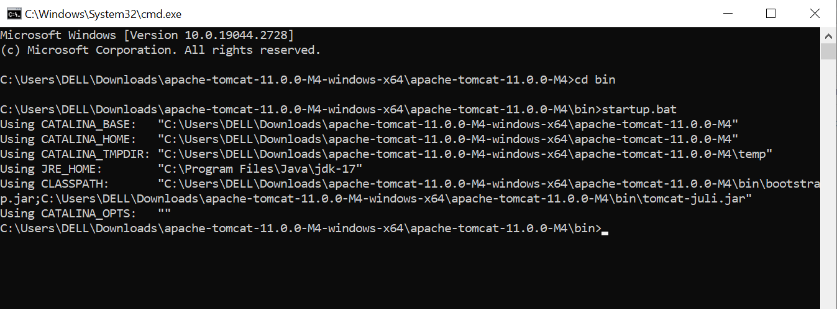

**First install tomcat from tomcat.apache.org**

**Then unzip it**

**Go to webapps folder then paste the Jenkins.war file in that**

**Go to cmd from there and go to bin**

**Then give startup.bat command**

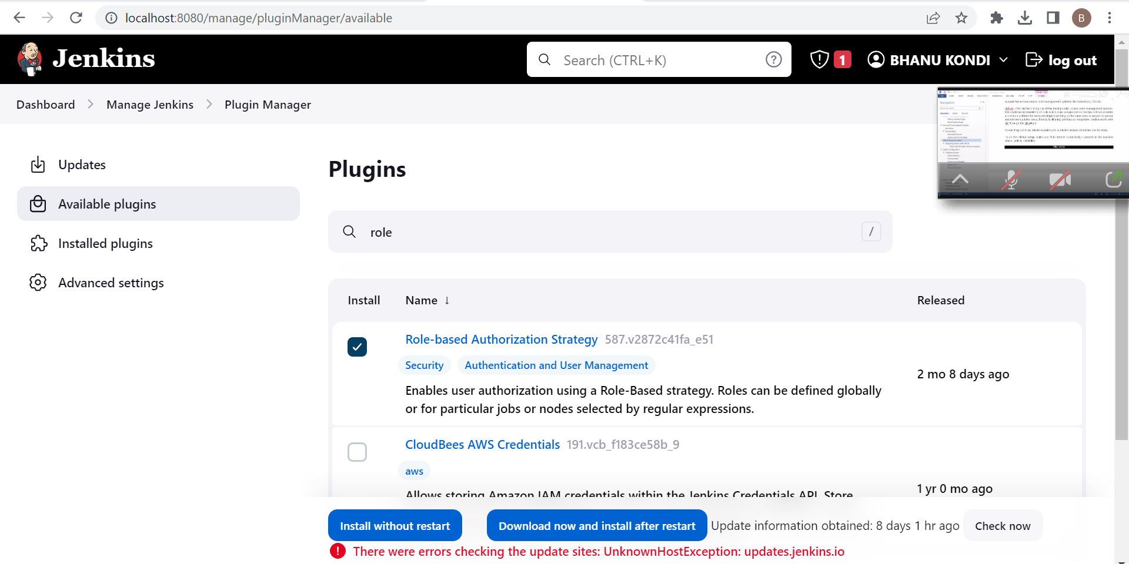

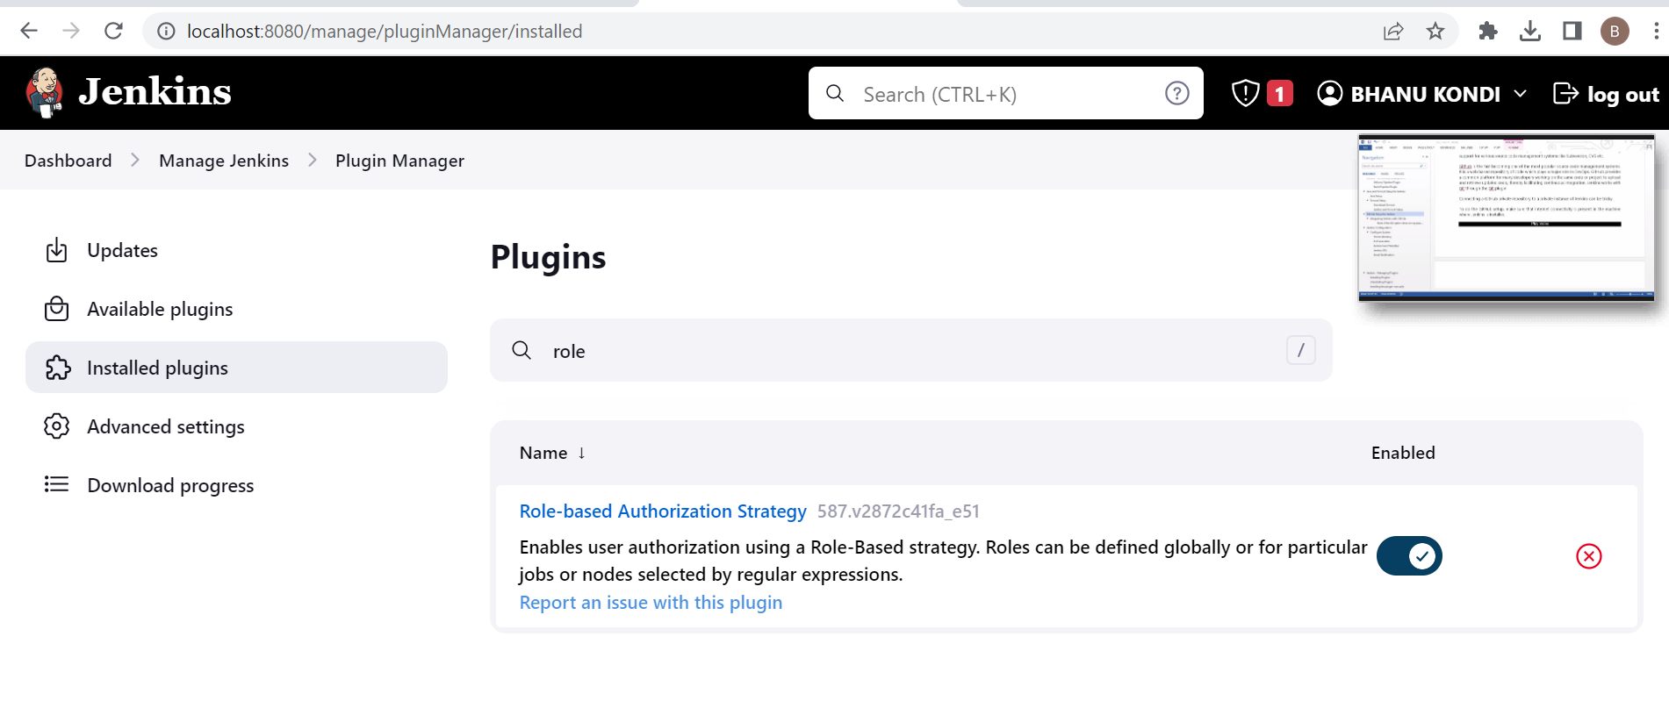

**Enable the role based strategy plugin**

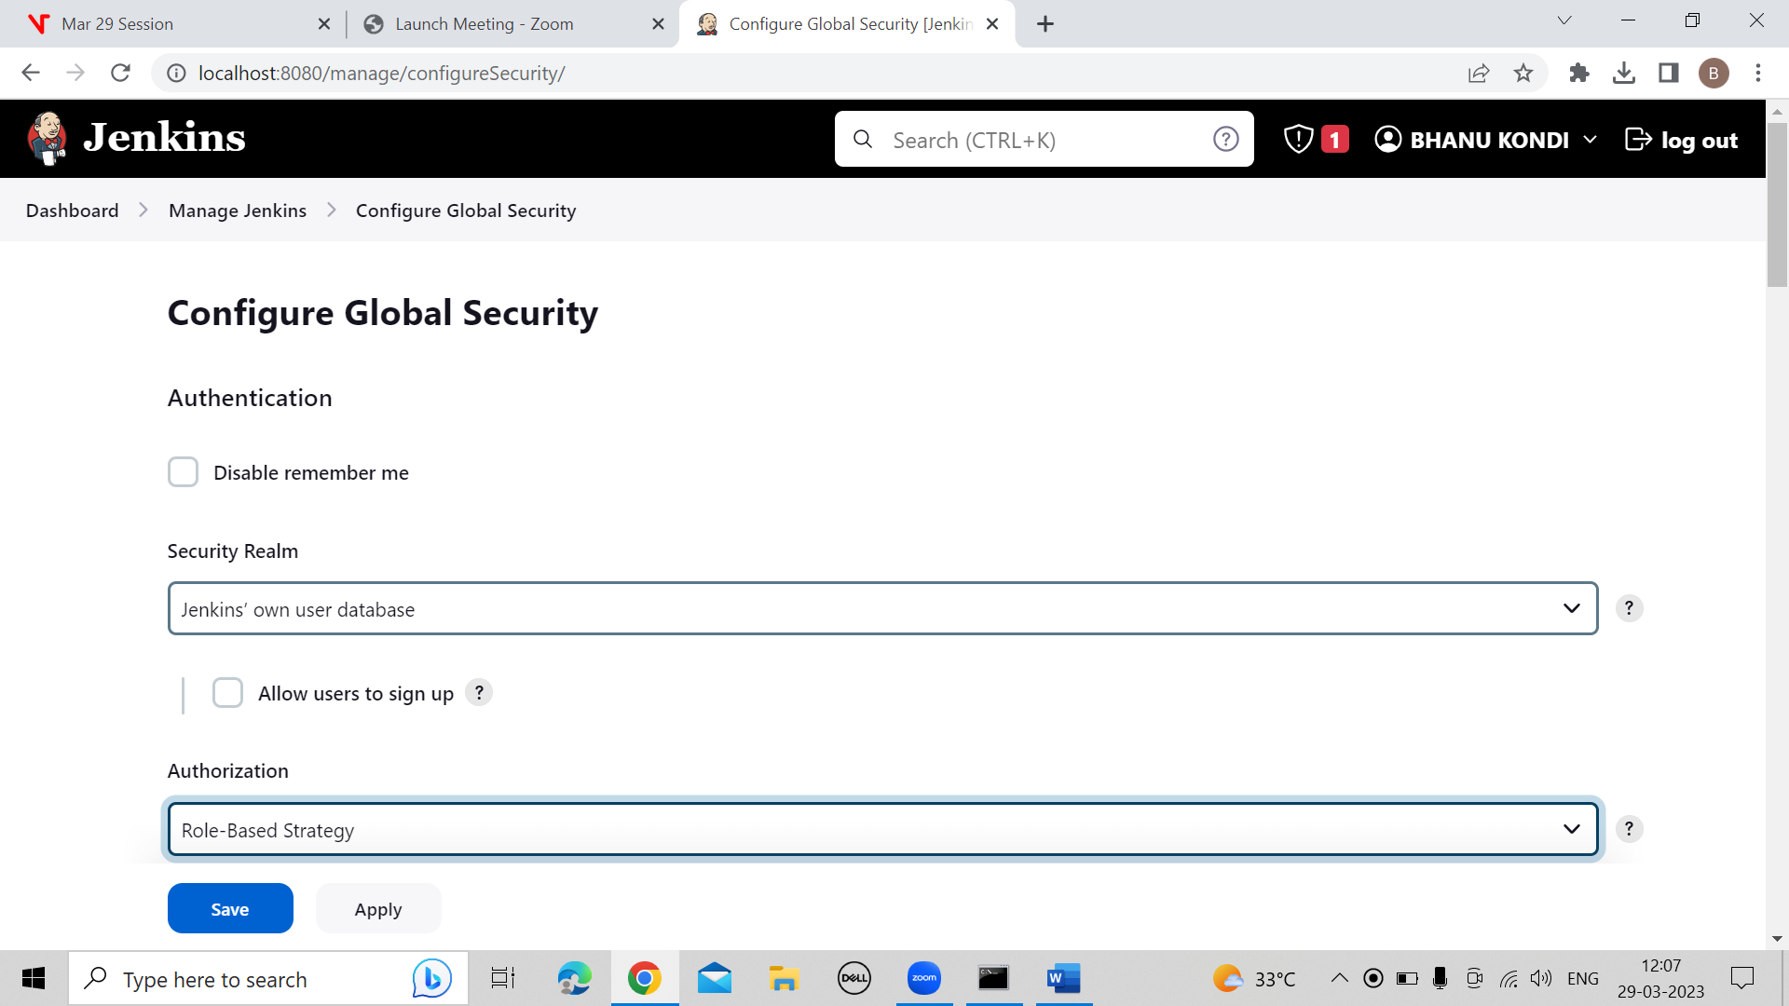

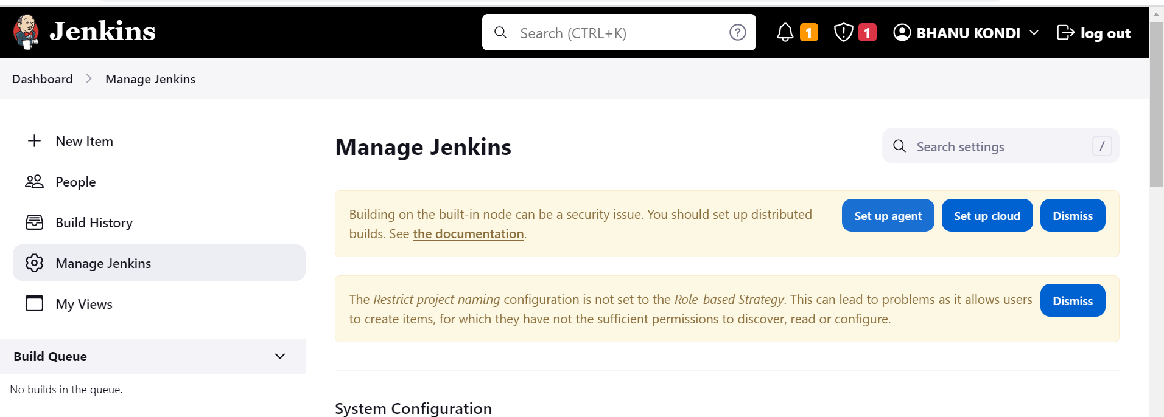

**Setup agent**

